**User Guide**

**TRADE**



USER GUIDE – TRADE

*Modern Statistics Platform*

**Revision History**

|  |  |  |  |
| --- | --- | --- | --- |
| Name | Date | Reasons of Changes | Version |
| iTM | 08th April 2024 | The first draft of Trade MauStats. | V1 |
| iTM | 18th June 2024 | The second draft of Trade MauStats. | V2 |
| iTM | 10th June 2024 | The third draft of Trade MauStats. | V3 |

Table of Contents

1.0 INTRODUCTION 4

2.0 TRADE 5

2.1 TRANSACTION 5

2.1.1 ADD 6

2.1.2 FILTER 12

2.2 ARCHIVE TRANSACTION 14

2.1.1 FILTER 14

2.3 ANNEXURE 1 – ARCHIVED TRANSACTION 16

# 1.0 INTRODUCTION

The Modern Statistics (MauStats) Platform is developed as a web-based platform with a central database to ensure consistency, security, and accessibility. The platform will help automate and integrate the data lifecycle from acquisition to dissemination using the Generic Statistical Business Process Model (GSBPM) framework. The platform complies with managing data requirements for Census, SEE, SBR, Demography, and Trade processed data in this phase. It is also feasible for data integration based on SM requirements. This web-based platform consists of two applications – User Interface and Data Management System (DMS).

In this user guide, we will be learning how to use the Trade module of the DMS application. The trade module allows to manage of the **Transaction** and **Archived** **Transaction** datasets.

The **Transaction** submodule allows to manage transaction datasets containing import transactions which have a minimum transaction amount of 1000 MRU whereasthe **Archived Transaction** submodule allows to viewing of those datasets that are excluded from the transaction dataset. These excluded transactions include ***Internal Transactions, Intermediate Transactions, And Transactions With Low Values (Less Than 1000)****.*

The below section explains the features and steps of using the Trade module.

# 2.0 TRADE

The Trade module has two submodules – Transaction and Archive Transaction. The module is developed to manage the external trade data of the country.

Let us learn how to use these submodules in detail.

## 2.1 TRANSACTION

This submodule allows authorized users to manage the transaction data

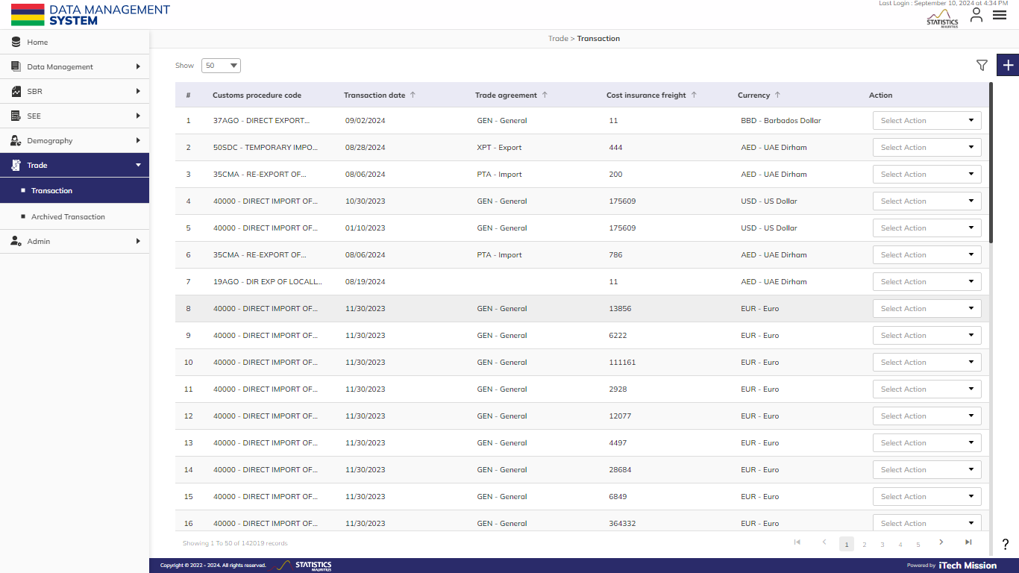**Step 1:** Click on the **Transaction** option available under the **Trade** module from the left panel to access this submodule. You have the option to add, edit, and archive the transaction records. You also have the option to search, sort, and view the existing records by page (see below figure).

This module allows the management of transaction datasets containing transactions with a minimum transaction amount of 1000 MRU (Monetary Currency Units).

### 2.1.1 ADD

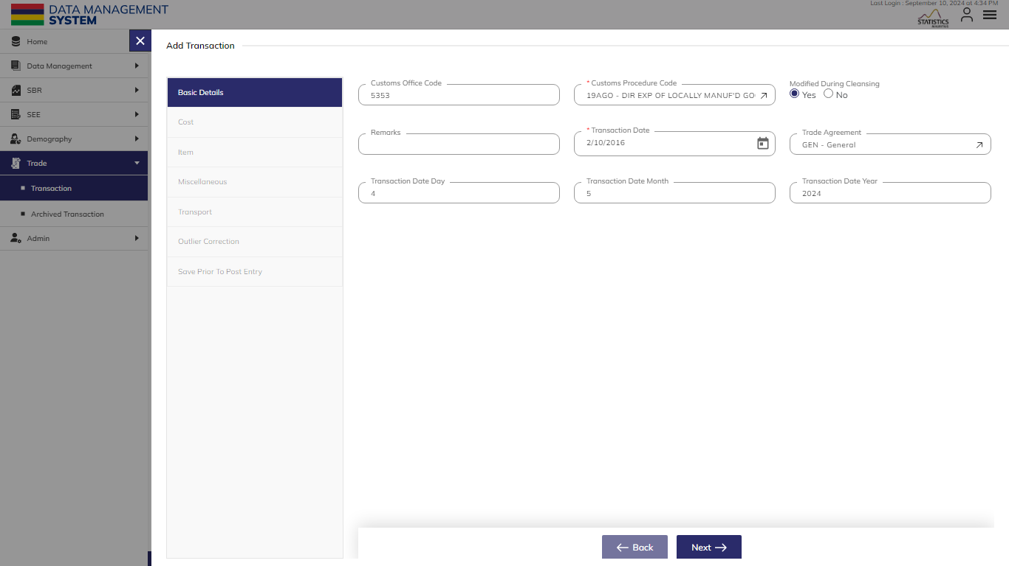**Step 2:** Click on the **Plus** button available on the right side of the page to add a new transaction record (see figure below).

The Add Transaction form is divided into sections namely – **Basic Details**, **Cost**, **Item**, **Miscellaneous**, **Transport, Outliner Correction** and **Save Prior to Post Entry**.

Enter the following information to add a new transaction record –

|  |  |  |  |  |
| --- | --- | --- | --- | --- |
| **Field** | **Type** | **Input Type** | **Mandatory** | **Associated Classification** |
| **Customs Procedure Code** | List | Single Choice | Yes | Civil status region codes |
| **Customs Office Code** | Text | Limit up to 5 characters | No |  |
| **Modified During Cleansing** | Checkbox | Boolean (Yes or No as value while importing) | No |  |
| **Remarks** | Text |  | No |  |
| **Transaction Date** | Date | Format – MM/DD/YYYY while importing | Yes |  |
| **Trade Agreement** | List |  | No | Trade Agreement |
| **Transaction Date Day** | Numeric |  | No |  |
| **Transaction Date Month** | Numeric |  | No |  |
| **Transaction Date Year** | Numeric |  | No |  |
| **Cost Insurance Freight** | Numeric |  | Yes |  |
| **Currency** | List |  | Yes | Alphabetic currency code |
| **Custom Duty** | Numeric |  | No |  |
| **Excise** | Numeric |  | No |  |
| **Free on Board** | Numeric |  | Yes |  |
| **Freight** | Numeric |  | No |  |
| **Insurance** | Numeric |  | No |  |
| **Levy** | Numeric |  | No |  |
| **Lost Exemption** | Numeric |  | No |  |
| **Other Costs** | Numeric |  | No |  |
| **VAT** | Numeric |  | No |  |
| **Bill Number** | Numeric |  | Yes |  |
| **Description of Goods** | Text |  | No |  |
| **HS Code** | List |  | Yes | Harmonised System (HS) Codes |
| **Item Number** | Numeric |  | Yes |  |
| **Net Weight** | Numeric |  | Yes |  |
| **Post Entry Code** | Text |  | No |  |
| **Quantity** | Numeric |  | Yes |  |
| **Country Other** | Text | Limit up to 12 characters | No |  |
| **Custom Spec** | Numeric | Limit up to 12 characters | No |  |
| **Excise Spec** | Numeric | Limit up to 12 characters | No |  |
| **Tr Version** | Numeric | Limit up to 12 characters | No |  |
| **Forbid Deletion** | Checkbox | Boolean (Yes or No as value while importing) | No |  |
| **Transaction Date Quarter** | Numeric | Limit up to 12 characters | No |  |
| **Transaction Date Semester** | Numeric | Limit up to 12 characters | No |  |
| **Type of Territory** | Numeric | Limit up to 12 characters | No |  |
| **Enterprise ID OID** | Numeric | Limit up to 12 characters | No |  |
| **Consignee Taxpayer Number** | Text | Limit up to 12 characters | No |  |
| **Country (of Transport)** | List |  | Yes | Country letter Code |
| **Importer Taxpayer Number** | Text | Limit up to 12 characters | Yes |  |
| **Mode of Transport** | List |  | Yes | Mode Of Transport |
| **Nationality** | List |  | Yes | Nationality |
| **Importer is EOE** | Checkbox | Boolean (Yes or No as value while importing) | No |  |
| **Consignee is EOE** | Checkbox | Boolean (Yes or No as value while importing) | No |  |
| **Importer Taxpayer Name** | Text |  | No |  |
| **Consignee Taxpayer Name** | Text |  | No |  |
| **Corrected On** | Date | Format – MM/DD/YYYY while importing | No |  |
| **Previous Unit Price** | Numeric | Limit up to 12 characters | No |  |
| **Previous Quantity** | Numeric | Limit up to 12 characters | No |  |
| **Number of Data Points** | Numeric | Limit up to 12 characters | No |  |
| **Min Unit Price** | Numeric | Limit up to 12 characters | No |  |
| **Median Unit Price** | Numeric | Limit up to 12 characters | No |  |
| **Median Absolute Deviations** | Numeric | Limit up to 12 characters | No |  |
| **Post Entry Modified** | Checkbox | Boolean (Yes or No as value while importing) | No |  |
| **Original CIF** | Numeric | Limit up to 12 characters | No |  |
| **Original FOB** | Numeric | Limit up to 12 characters | No |  |
| **Original Quantity** | Numeric | Limit up to 12 characters | No |  |
| **Original Net Weight** | Numeric | Limit up to 12 characters | No |  |

Click on the **Save** button to save and confirm. You can now view the new transaction record added to the list.

The combination of Bill Number, Item Number, and Transaction Date are considered as a **unique record.**

**Step 4:** Select the **Edit** option available in the action dropdown to edit the details of the selected element. Edit the required detail and click on the update button to save and confirm.

**Step 5:** Selectthe **Delete** option available in the action dropdown to delete the selected element. A confirmation popup appears, click **Yes** to confirm the deletion of the selected element.

**Step 6:** Click to select the **Archive Transaction** option available in the action dropdown to mark the transaction as archived.

### 2.1.2 FILTER

**Step 7:** Click the **Filter** button on the right side of the page to **Filter** the **Transaction** list based on the specified criteria.

Suppose you want to **Filter** the record where the “Customs Procedure Code” is “equal to” <90008 - IMPORT OF RAW MATERIALS>.

The above statement comprises -

* Enter **Filter Name**
* “Customs Procedure Code “as **Column**
* “Equal to (=)” as **Operator**
* <90008 - IMPORT OF RAW MATERIALS> as **Value**

*All the blue color details are mandatory to be entered.*

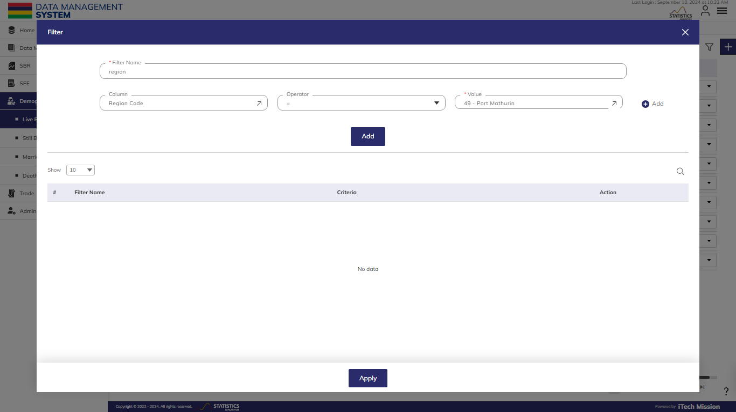Click on the **Add** button to confirm saving the **Filter**. You can apply multiple criteria by adding multiple **Filter**s one by one following a similar approach to add each one separately. You can also add multiple **Filter**s at once by clicking on the **Plus** button available in the first **Filter** row (see below figure).

**NOTE:**

To filter a dataset based on multiple conditions, if you need all conditions to be true (e.g., records where Mode of Transport is 2 – Air **AND** Country is AU - Australia), apply the filters separately. For conditions where one of the conditions needs to be true (e.g., records where Mode of Transport is 2 – Air **OR** Country is AU - Australia), combine the filters.

Click on the **Apply** button to **Filter** the **Transaction** list based on saved **Filter**s.

## 2.2 ARCHIVE TRANSACTION

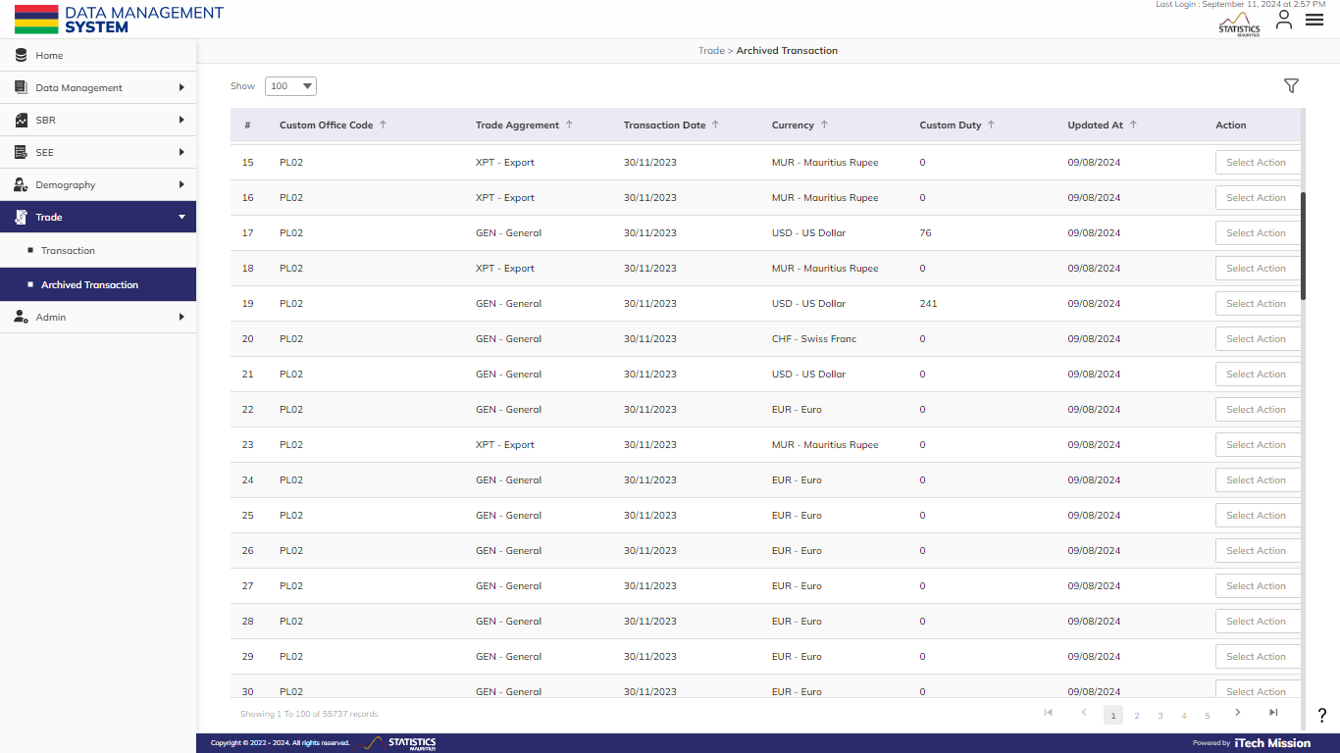Click on the **Archived** **Transaction** option available under the **Trade** module from the left panel to access this submodule (see below figure).

This submodule allows the authorized users to search and view those datasets that are excluded from the **Transaction** dataset. These excluded **Transactions** include internal transactions, intermediate transactions, and transactions with low values (less than 1000).

### 2.1.1 FILTER

**Step 8:** Click the **Filter** button on the right side of the page to **Filter** the **Archived Transaction** list based on the specified criteria.

Suppose you want to **Filter** the record where the “Customs Procedure Code” is “equal to” <90008 - IMPORT OF RAW MATERIALS>.

The above statement comprises -

* Enter **Filter Name**
* “Customs Procedure Code “as **Column**
* “Equal to (=)” as **Operator**
* <90008 - IMPORT OF RAW MATERIALS> as **Value**

*All the blue color details are mandatory to be entered.*

Click on the **Add** button to confirm saving the **Filter**. You can apply multiple criteria by adding multiple **Filter**s one by one following a similar approach to add each one separately. You can also add multiple **Filter**s at once by clicking on the **Plus** button available in the first **Filter** row (see below figure).

**NOTE:**

To filter a dataset based on multiple conditions, if you need all conditions to be true (e.g., records where Mode of Transport is 2 – Air **AND** Country is AU - Australia), apply the filters separately. For conditions where one of the conditions needs to be true (e.g., records where Mode of Transport is 2 – Air **OR** Country is AU - Australia), combine the filters.

Click on the **Apply** button to **Filter** the **Transaction** list based on saved **Filter**s.

## 2.3 ANNEXURE 1 – ARCHIVED TRANSACTION

* For Internal transactions where the country in MU, FRP, ROD, WT, SBO, AGA will be automatically moved to Archived Transaction.
* For transactions with **Cost Insurance Freight** (CIF) < 1000, it will be automatically moved to Archived Transaction.
* For transactions with **Free on Board** (FOB<1000), it will be automatically moved to Archived Transaction.
* For transactions with CPC having Trade type NONE, it will be automatically moved to Archived Transaction.
* Transactions based on Trade Flow Subclass in
  + 14 - Ignored export transaction (T-Used),
  + 19 - Other export type,
  + 24 - Ignored import transaction (T-Used),
  + 25 - Import by freeport - local sales (ignored),
  + 29 - Other import type
  + it will be automatically moved to Archived Transaction.
* For transactions where HS code for all non-post-entry, non-ship-stores, it will be automatically moved to Archived Transaction.



PRODUCT DOCUMENT